SUBJECT: OBJECT ORIENTED PROGRAMMING

Submitted To: Engr. Asmatullah

Submitted By: Asadullah Samo (21SW036)

Dated: 24-08-2022

Lab: Lab-08 Tasks

**Question 01:**

Write a java program in which exception is handled if number is divided by zero and print the exception name.

Source Code:

**package** Lab_08_Tasks;

**import** java.util.Scanner;

**public** **class** Lab_08_Task_01 {

**public** **static** **void** main(String[] args) {

Scanner sc = **new** Scanner(System.in);

System.out.print("Enter a number: ");

**int** num = sc.nextInt();

**try**{

System.out.println(num/0);

}

**catch**(ArithmeticException ae){

System.out.println("Exception named \'"+ae.getMessage()+"' occurred");

} // end of try catch block

} // end of main() method

} // end of program

OUTPUT:

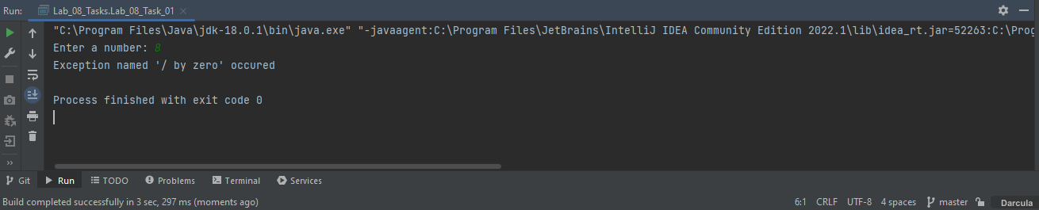

**Question 02:**

Write a java program in which takes an input from the user if his/her age is less than 18 then throw a user defined exception. User defined exception class must include two methods of eligible and not eligible.

Source Code:

**package** Lab_08_Tasks;

**import** java.util.Scanner;

**import** java.lang.Exception;

**class** Eligibility **extends** Exception{

**public** **void** eligible(){

System.out.println("You are eligible");

}

**public** **void** notEligible(){

System.out.println("You are not eligible");

}

}

**public** **class** Lab_08_Task_02 {

**public** **static** **void** main(String[] args) {

Scanner sc = **new** Scanner(System.in);

Eligibility e = **new** Eligibility();

System.out.print("Enter your age: ");

**int** age = sc.nextInt();

**try** {

**throw** **new** Eligibility();

}

**catch**(Exception ie){

**if**(age<18)

e.notEligible();

**else**

e.eligible();

}

} // end of main() method

} // end of program

OUTPUT:

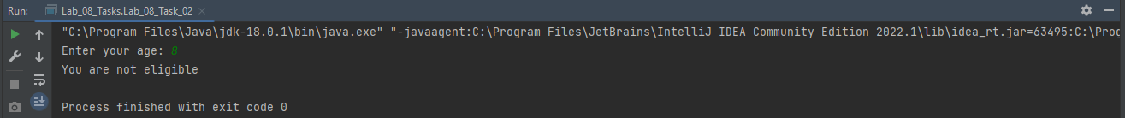

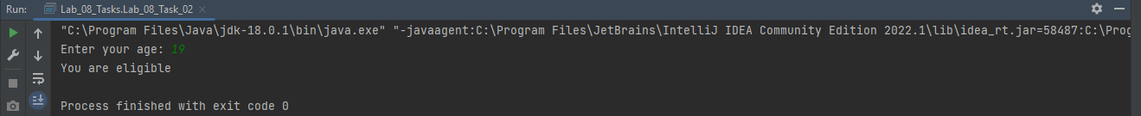

**Question 03:**

Create a new InvalidPasswordFormatException which throws an exception on following scenarios:

1) Password is less than 8 characters.

2) Password has Asterik(*)

**Source code:**

**package** Lab_08_Tasks;

**import** java.util.Scanner;

**class** InvalidPasswordFormatException **extends** Exception{

**public** **void** lessChars(){

System.out.println("Characters are less than 8");

}

**public** **void** asterik(){

System.out.println("Password contains *");

}

}

**public** **class** Lab_08_Task_03 {

**public** **static** **void** main(String[] args) {

InvalidPasswordFormatException in = **new** InvalidPasswordFormatException();

Scanner sc = **new** Scanner(System.in);

System.out.println("Enter your password");

String password = sc.nextLine();

**int** length = password.length();

**try**{

**throw** **new** InvalidPasswordFormatException();

}

**catch**(Exception e){

**if**(password.contains("*"))

in.asterik();

**else** **if**(password.contains("*") && length<8)

in.asterik();

**else** **if**(length<8)

in.lessChars();

**else**

System.out.println("No exception");

} // end of try catch block

} // end of main() method

} // end of program

